Session – 2
Assignment 2
- Install GCC on your computer and verify the installation by running gcc --version in your terminal or command prompt.

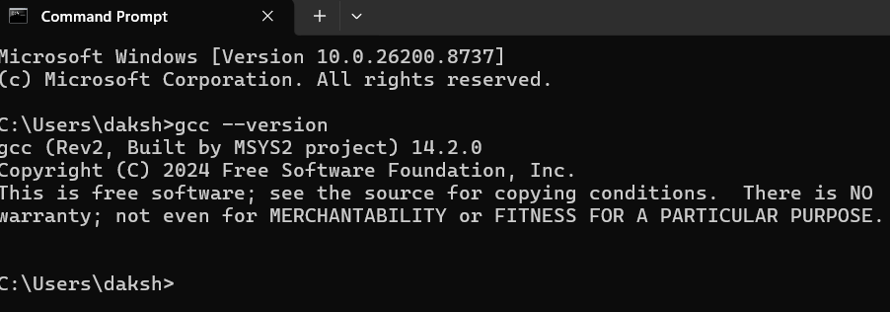

- Open VS Code or DevC++ and create a new file named hello.c. Write a C program that prints 'Hello, Instagram World!' to the console.
- #include<stdio.h>
main()
{
printf(“Hello!!”);
printf(“Instagram World”);
}

Output:-

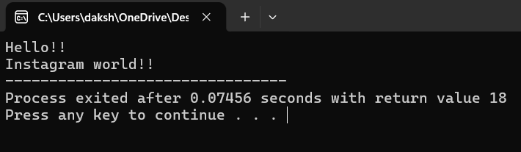

- Identify and label the header, main function, and return statement in your hello.c program using comments.

// HEADER FILE: Includes standard input/output library functions like printf
#include <stdio.h>

// MAIN FUNCTION: The primary entry point where program execution begins
int main() {

// Prints "Hello, World!" to the console screen
printf("Hello, World!\n");

// RETURN STATEMENT: Ends the main function and signals successful execution (0) to the OS
return 0;
}

- Compile your hello.c file using the GCC command line (gcc hello.c -o hello) and run the output file to display the message in your terminal.<br><br><em><strong>Hint:</strong> On Windows, the output file will be hello.exe; on Linux/Mac, it will be hello.</em>

